# freETarget

Application Note: Building freETarget Basic

**SUMMARY**

One goal of freETarget was to make electronic targets accessible to a wide range of people around the world. freETarget Basic is the simplest construction that can be made using local material. The document is organized as:

* Building the target frame
* Installing the circuit
* Downloading the PC software
* Starting up
* Trouble shooting

The example shown here is made from plywood and plastic. You may choose to assemble it with different materials.

**REQUIRED**

* freETarget circuit
* Cardboard or similar material
* Internet connection
* Hand tools
* Patience

**IMPORTANT**

This application note is provided as a minimal means of building freETarget. Cardboard has **NO** protection form pellets or bullets. Shooting outside of the target area can have severe consequences to the circuit or surrounding material.

The reader is responsible for any damage that could be caused by shooting into this target holder.

**INTRODUCTION**

freETarget is an open source project to provide shooters with a low cost electronic target. One of the objectives is that the materials needed to make the target will be sourced from around the world and will be dependent on what is available locally. To do this, much of the initiative to tailor the construction to your skills and parts availability is comes from people like you.

This application note provides the basics to construct freETarget from cardboard. Read all of the instructions before starting. You may have to change materials or operations based on what you have at hand.

**BUILDING THE TARGET FRAME**

The target frame holds the target and sensors in the correct position to record the shot. The assembly can be made of anything local, such as

* Cardboard
* 3D Printed sensor mounts
* Hot glue or similar
* Duct tape or similar
* Paper Clips

A side view of the target assembly is shown in Figure 1.

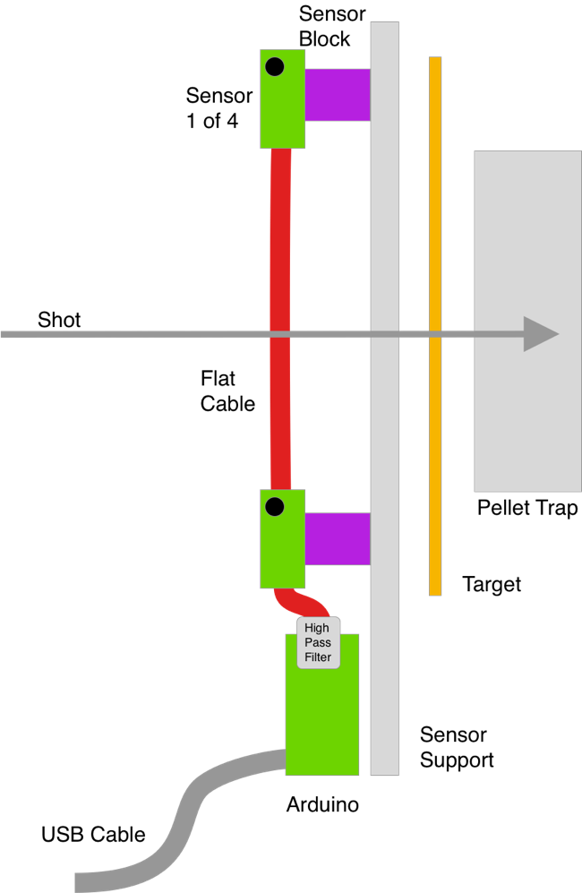

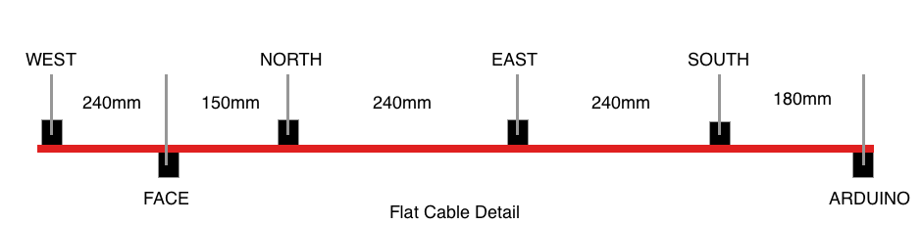

Figure 1: freETarget Layout

|  |  |  |
| --- | --- | --- |
| Item | Description | Notes |
| Sensor | Four microphones located around the target to detect the shot | Pay careful attention to the locations stenciled on the circuit board.  Sensors may be located anywhere between the front face and pellet trap. |
| Flat Cable | Routes from the Arduino board to the sensors | End marked with an A is the Arduino end of the cable |
| High Pass Filter | Small board that installs between the flat cable and Arduino | Used to attenuate report from gun |
| Sensor Block | Mounting block to hold sensor parallel to direction of shot | May be any non-conductive material. |
| Sensor Support | Back frame to hold the sensors in the correct location and orientation |  |
| Target | Target | May be located anywhere between the front face and pellet trap. |
| Pellet Trap | Pellet Trap | Used to collect pellets after shooting.  May be omitted if shooting on a range with a berm. |
| USB Cable | Fifteen meter USB cable | May be purchased locally or on line |

Start marking the heavy cardboard as shown in Figure 2.

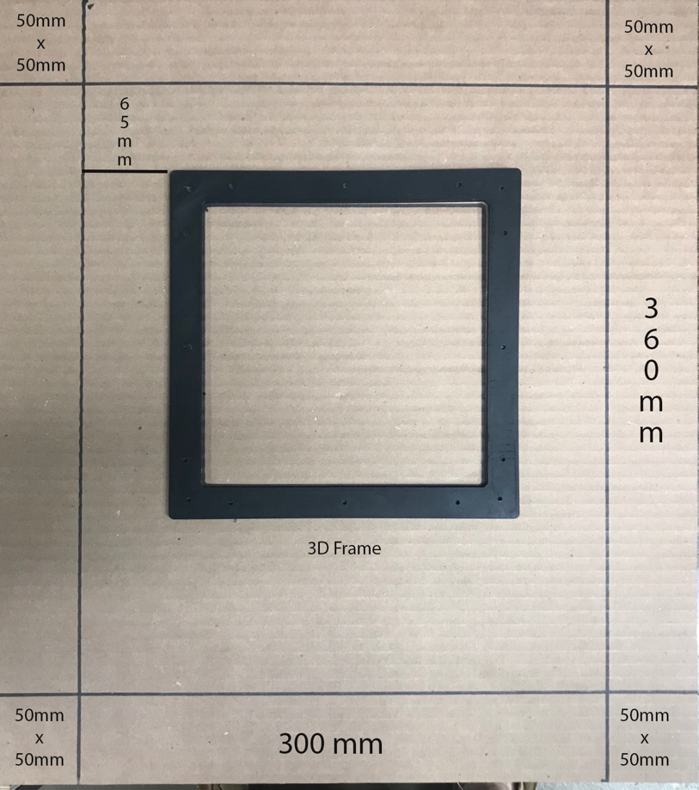

Figure 2: Marked Cardboard

Cut out the corners and target hole as illustrated in Figure 3. From the opposite side, cut or score the cardboard along the perimeter lines.

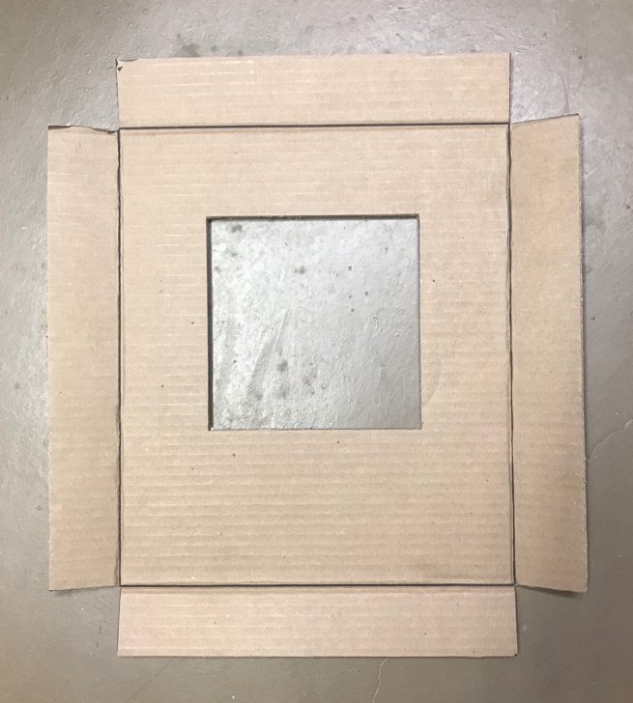

Figure 3: Cut Cardboard

Along the scored lines, fold the cardboard inward to form a box as shown in Figure 4. Hold the corners in place with tape or glue.

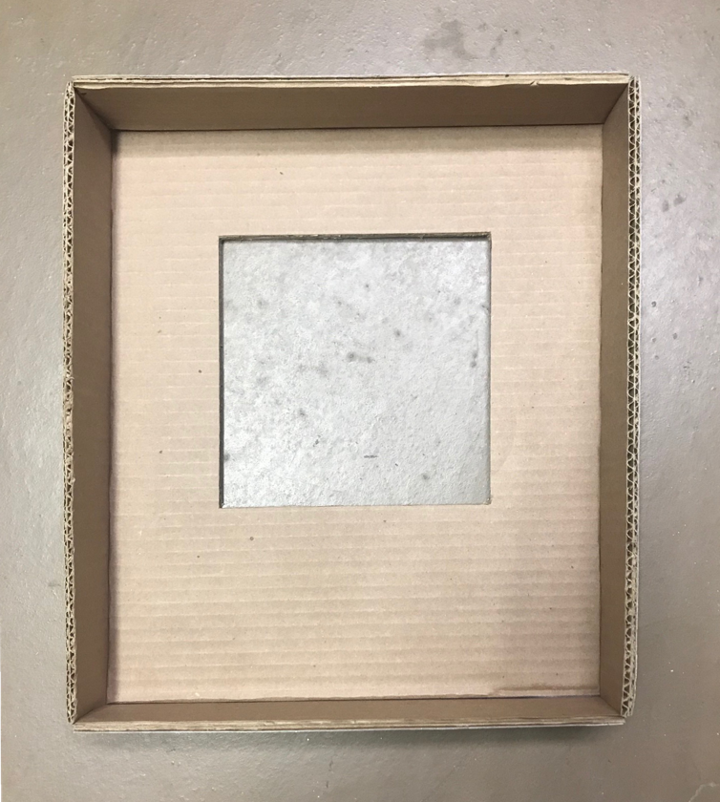

Figure 4: Folded Box

Using hot glue or some adhesive, locate the 3D Printed parts as shown in Figure 5.

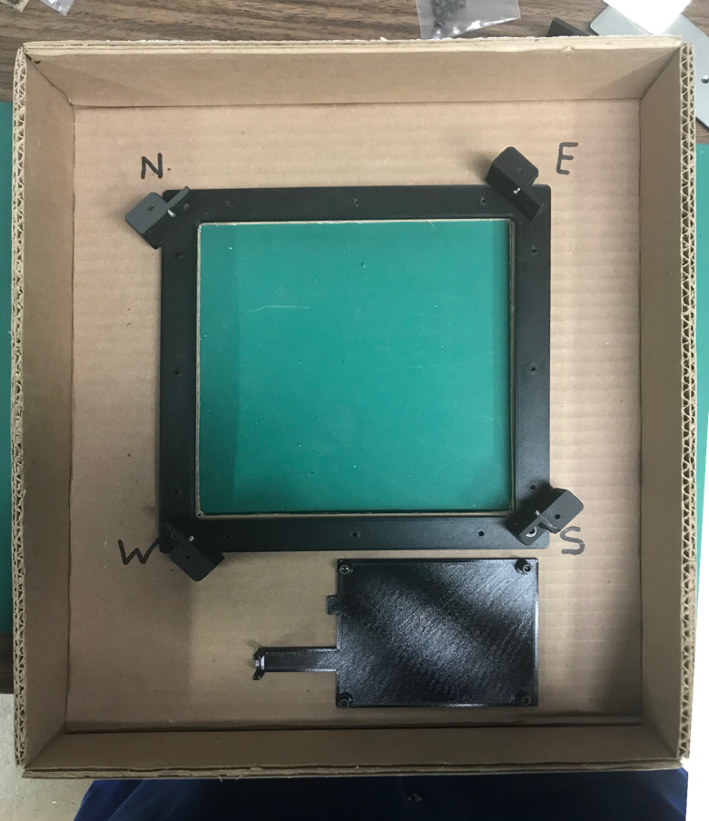

Figure 5: 3D Printed Parts Installed

Install the circuits per Figure 6. Pay attention to installing the sensors in the correct location, ex North to North…

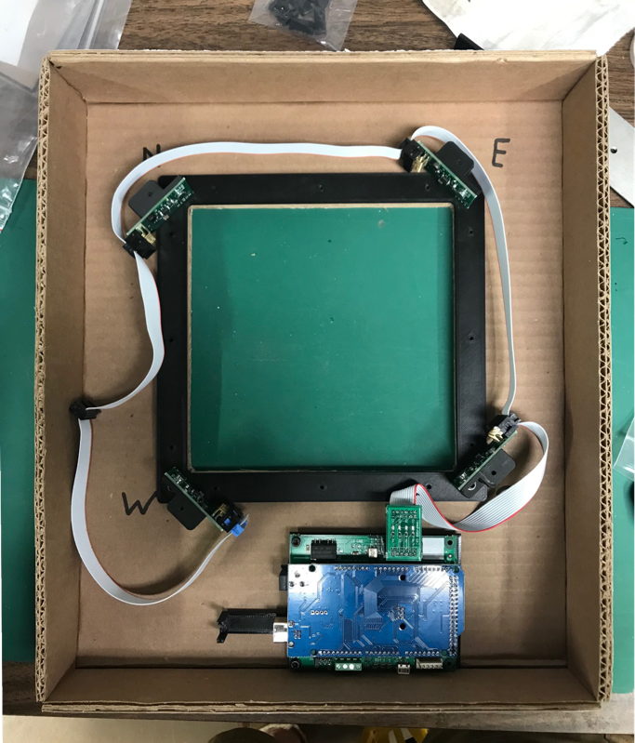

Figure 6: Installed Circuits

The last step is to attach the target holder. Attach two paper clips to a target and center the target over the hole. Hot glue the paper clips in place. Mark the four corners of the target to consistently locate the target. See Figure 7 for an illustration

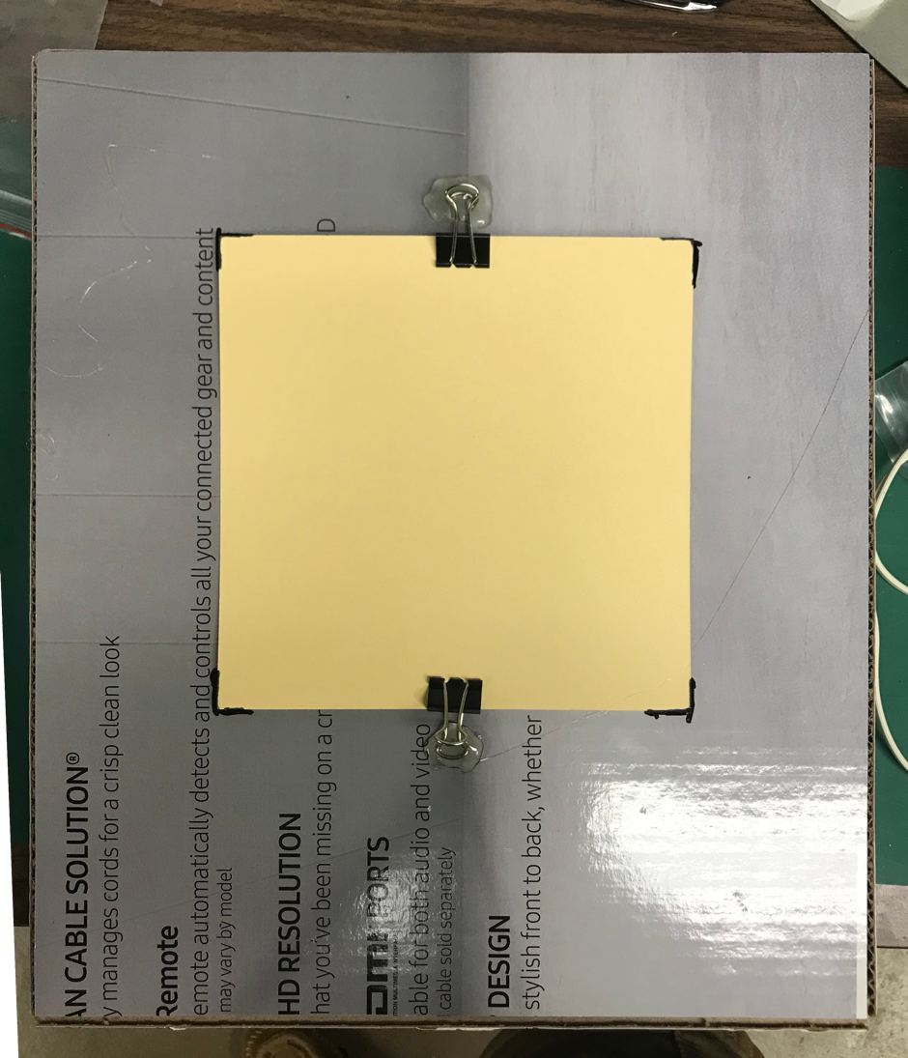

Figure 7: Target Paper Clips

Locate the bullet trap behind the target holder.

DOWNLOADING AND INSTALLING PC SOFTWARE

Click the link below to go to the downloads page

<https://free-e-target.com/downloads/>

Look for the PC Software section and download the software (Figure 8)

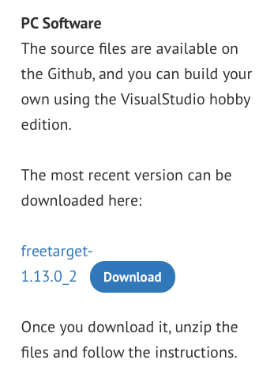

Figure 8: Download Software

Unzip the software and install on your PC.

Connect the USB cable between the target holder and the PC.

**STARTING UP**

Launch the PC program and look for the setup icon (GEAR WHEEL) in the upper right corner (See Figure 9)

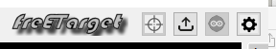

Figure 9: Setup Icon Location

Enter all of the setup information needed in Figures 9, 10, 11, and 12

|  |  |  |  |
| --- | --- | --- | --- |
|  |  |  |  |
| Figure 10: General Settings | Figure 11: Target Settings | Figure 12: Sensor Adjustment | Figure 13: Hardware Interface |

Figure 10: This allows you to enter the shooter name and how information will be stored.

Figure 11: Choose the target you will be shooting against and the colours you will be using.

Figure 12: Fine tune the sensor position to adjust for assembly errors

Figure 13: Interface to the target hardware.

Press 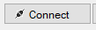 to begin a session.

Refer to the Commissioning Instructions from the web site. This will give you a quick summary of how the system is working

TROUBLESHOOTING

The boards are tested before shipment, but a lot can happen between the last test and the first shot. If your system is not working, please follow the trouble shooing guide below before sending an email to freETarget.com

|  |  |
| --- | --- |
| No Shots Registered | * Check that the USB cable is attached * Check that the correct Serial port is set in the setup * Check that the wiring harness is attached to all of the sensors * Tap each of the sensors. Do the three LEDs blink? |
| Shots show up but in the wrong place | * From the firing line, shoot a blank shot   + Do the three LEDs blink?     - Yes, set a new trip point     - No, Check all of the wiring * Verify that the sensors North – West are in the correct order |
| The shots show up but rotated 90 degrees | * Verify the order of the sensors and correct |
| The shots are the mirror image left-right | * The sensors are reversed. Switch the positions of NORTH-EAST and SOUTH-WEST |

Appendix A: freETarget Components

